**Solving an SDG Problem with Data**

**Requirements**

**Part 1: SDG Selection and Problem Definition**

* ***SDG Selection*:**
* **SDG 2: Zero Hunger:**
* **Problem Definition:**
* Food insecurity, which will also be considered in SDG 2, is a major issue affecting urban areas. Most of the populations are suffering due to not having enough volume of food that is accessible and affordable. The ultimate result of such food insecurity is malnutrition and hence health problems. This project therefore looks forward to analyzing the food distribution network to assess the gaps in access to food resources

**Part 2: Database Design**

* **ERD:** Entities to include:
* **Users** (Farmers, Distributors, Consumers)
* **Products** (Food items)
* **Orders** (Purchase records)
* **Locations** (Urban areas)

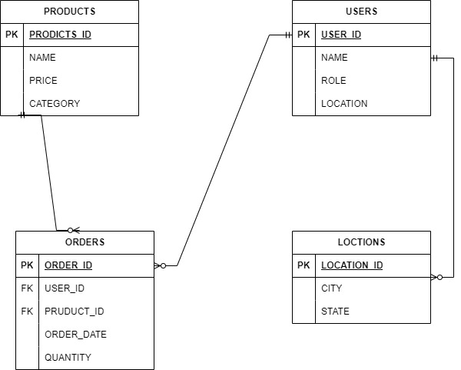

* **Schema:** Write SQL statements to create the database schema based on your ERD.
* CREATE TABLE Users (

user_id INT PRIMARY KEY,

name VARCHAR(100),

role VARCHAR(50),

location VARCHAR(100)

);

* CREATE TABLE Products (

product_id INT PRIMARY KEY,

name VARCHAR(100),

price DECIMAL(10, 2),

category VARCHAR(50)

);

* CREATE TABLE Orders (

order_id INT PRIMARY KEY,

user_id INT,

product_id INT,

order_date DATE,

quantity INT,

FOREIGN KEY (user_id) REFERENCES Users(user_id),

FOREIGN KEY (product_id) REFERENCES Products(product_id)

);

* CREATE TABLE Locations (

location_id INT PRIMARY KEY,

city VARCHAR(100),

state VARCHAR(100)

);

* **Sample Data:**
  + INSERT INTO Users VALUES (1, 'Alice Smith', 'Farmer', 'Downtown');
  + INSERT INTO Users VALUES (2, 'Bob Johnson', 'Consumer', 'Uptown');
  + INSERT INTO Products VALUES (1, 'Carrot', 0.75, 'Vegetable');
  + INSERT INTO Products VALUES (2, 'Apple', 1.00, 'Fruit');
  + INSERT INTO Orders VALUES (1, 2, 1, '2024-09-01', 10); -- Bob orders 10 carrots
  + INSERT INTO Orders VALUES (2, 2, 2, '2024-09-02', 5); -- Bob orders 5 apples
  + INSERT INTO Locations VALUES (1, 'Downtown', 'NY');
  + INSERT INTO Locations VALUES (2, 'Uptown', 'NY');

**Part 3: SQL Programming**

* **Data Retrieval:**
* SELECT name, role FROM Users WHERE role = 'Consumer';
* **Data Analysis:**
  + SELECT Products.name, SUM(Orders.quantity) AS TotalSold
  + FROM Orders
  + JOIN Products ON Ordersproduct_id = Products.product_id
  + GROUP BY Products. name;

**Part 4: Data Analysis Using Excel**

* **Import Data:**
* **Analysis:**
* **Dashboard:**

**Part 5: Integration and Testing**

* **Integration:**
  + check the table in your schema
  + find the export tab.
  + Export to your local machine in xls format
  + Open in Excel and confirm for any duplicates or blanks and correct them.
* **Testing:** Test the integration and functionality of your Excel dashboard.

**Part 6: Presentation**

* **Pitch Deck:**
* https://gamma.app/docs/Revolutionizing-Food-Security-Bridging-the-Gap-between-Farms-and--wkk7owq386yqj0o?mode=doc

.